# CS 255 System Design Document Template

## UML Diagrams

### UML Use Case Diagram

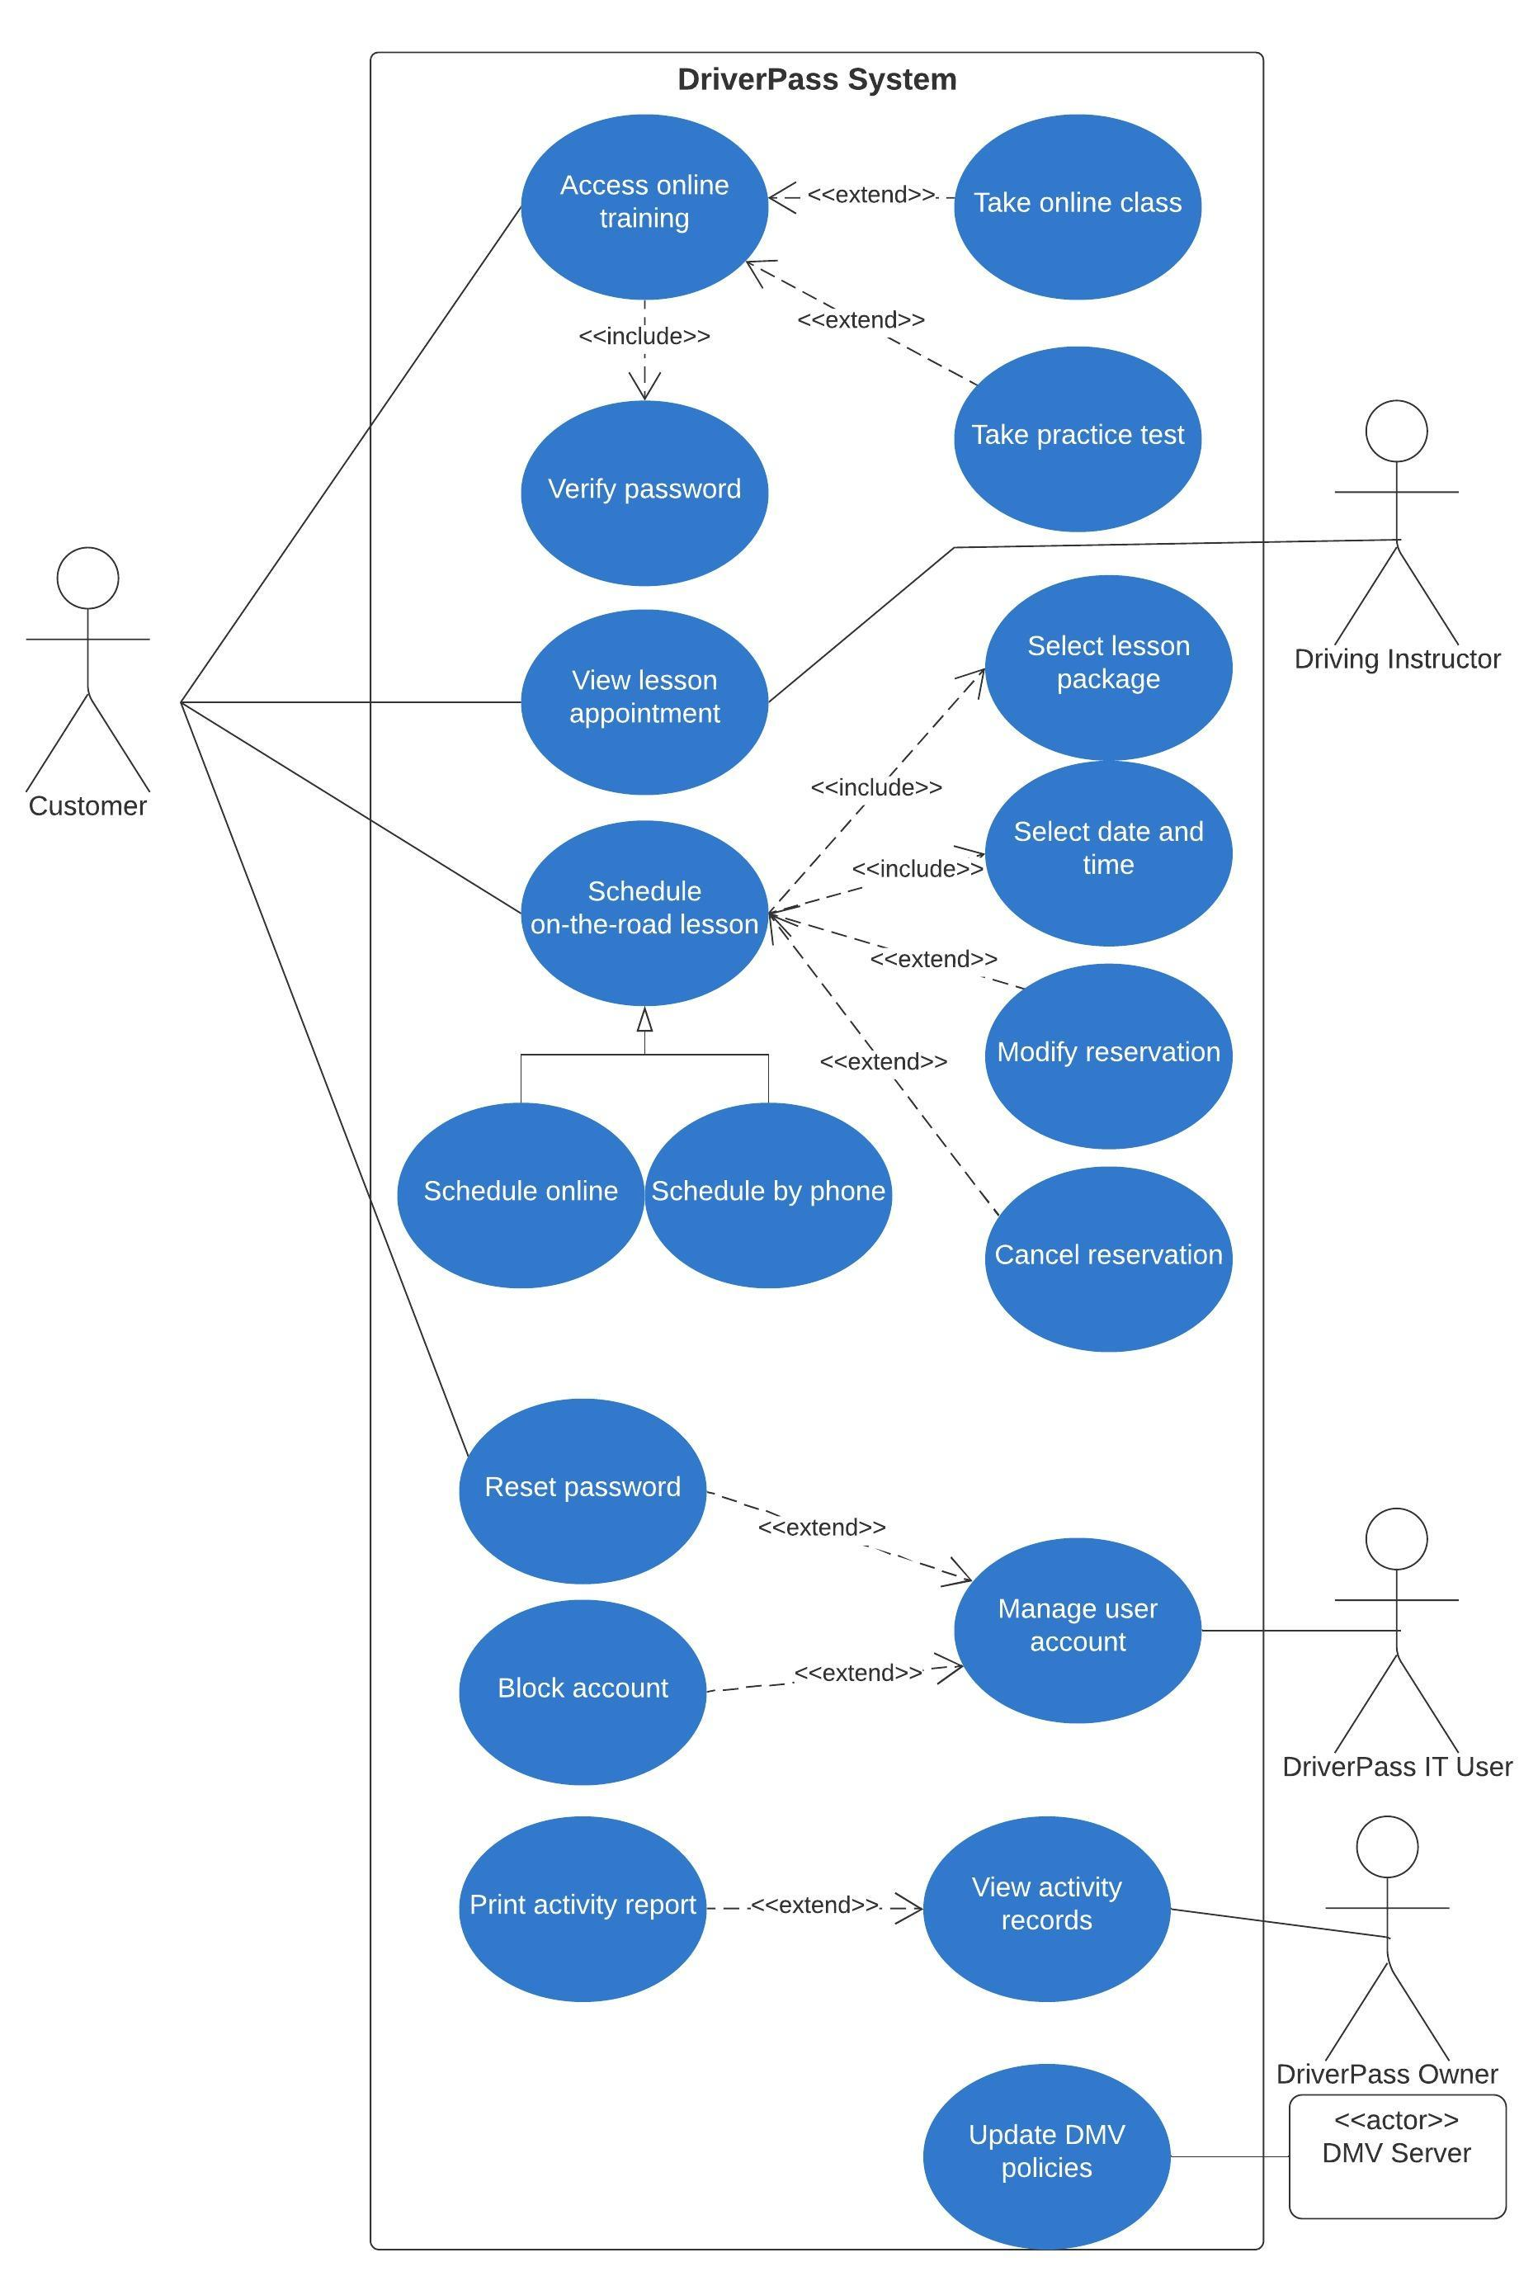

### UML Activity Diagrams

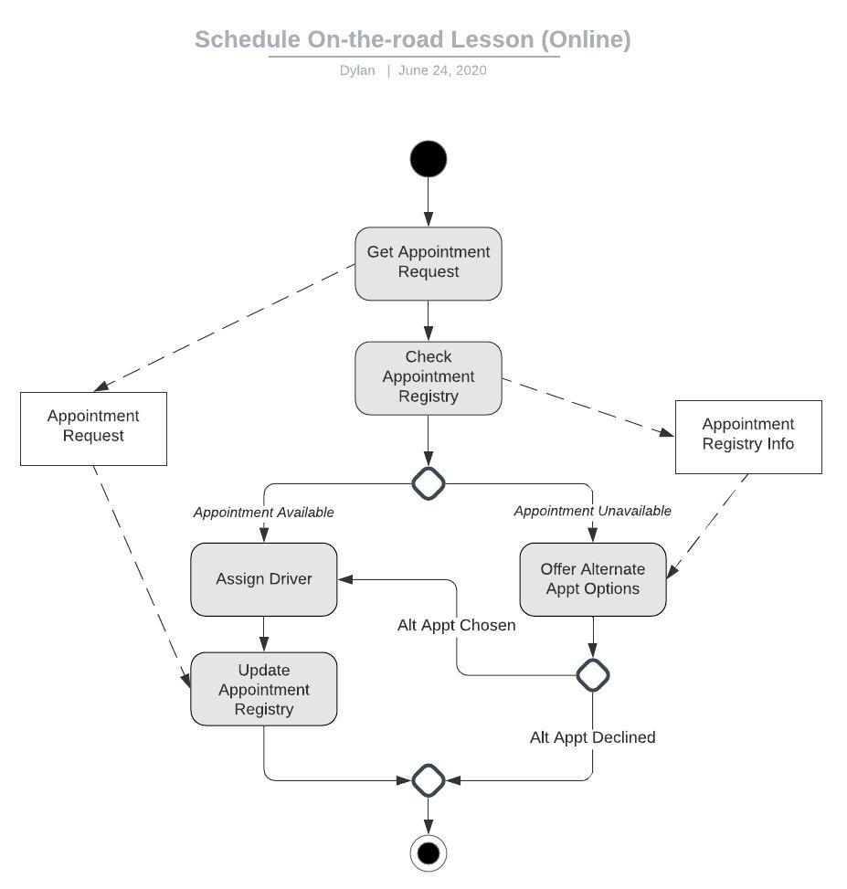

### UML Activity Diagrams (continued)

### 

### UML Sequence Diagram

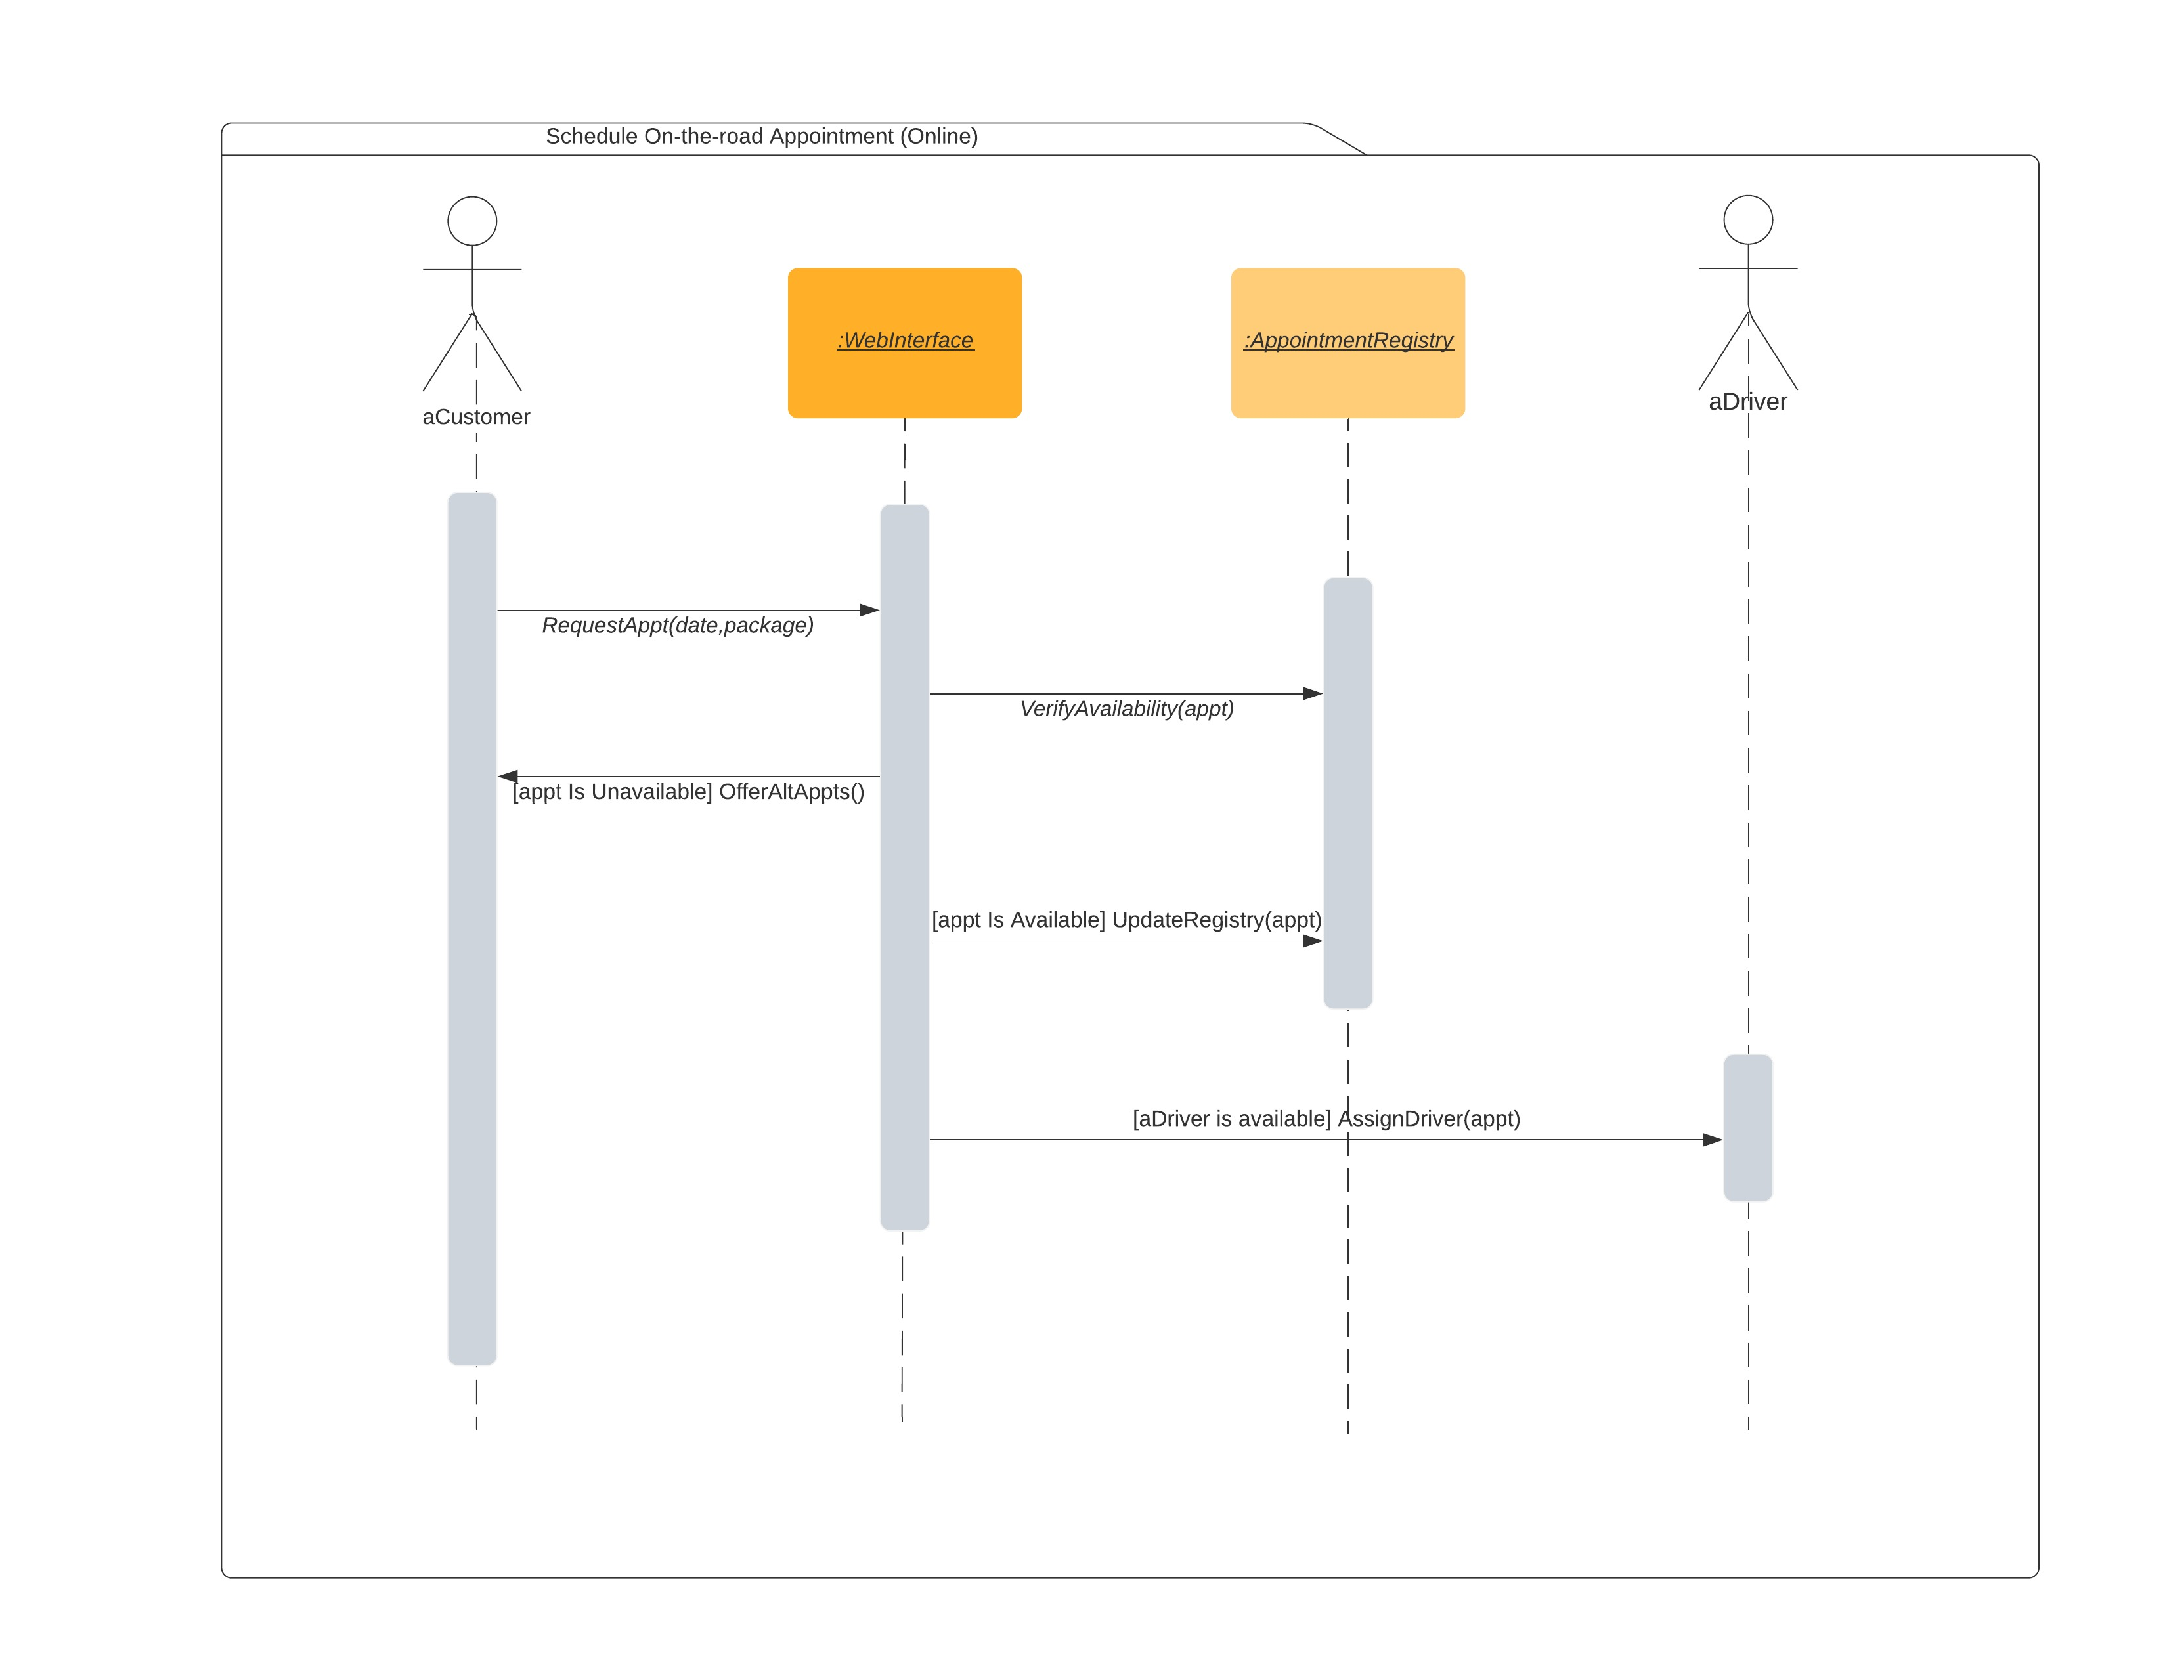

### UML Class Diagram

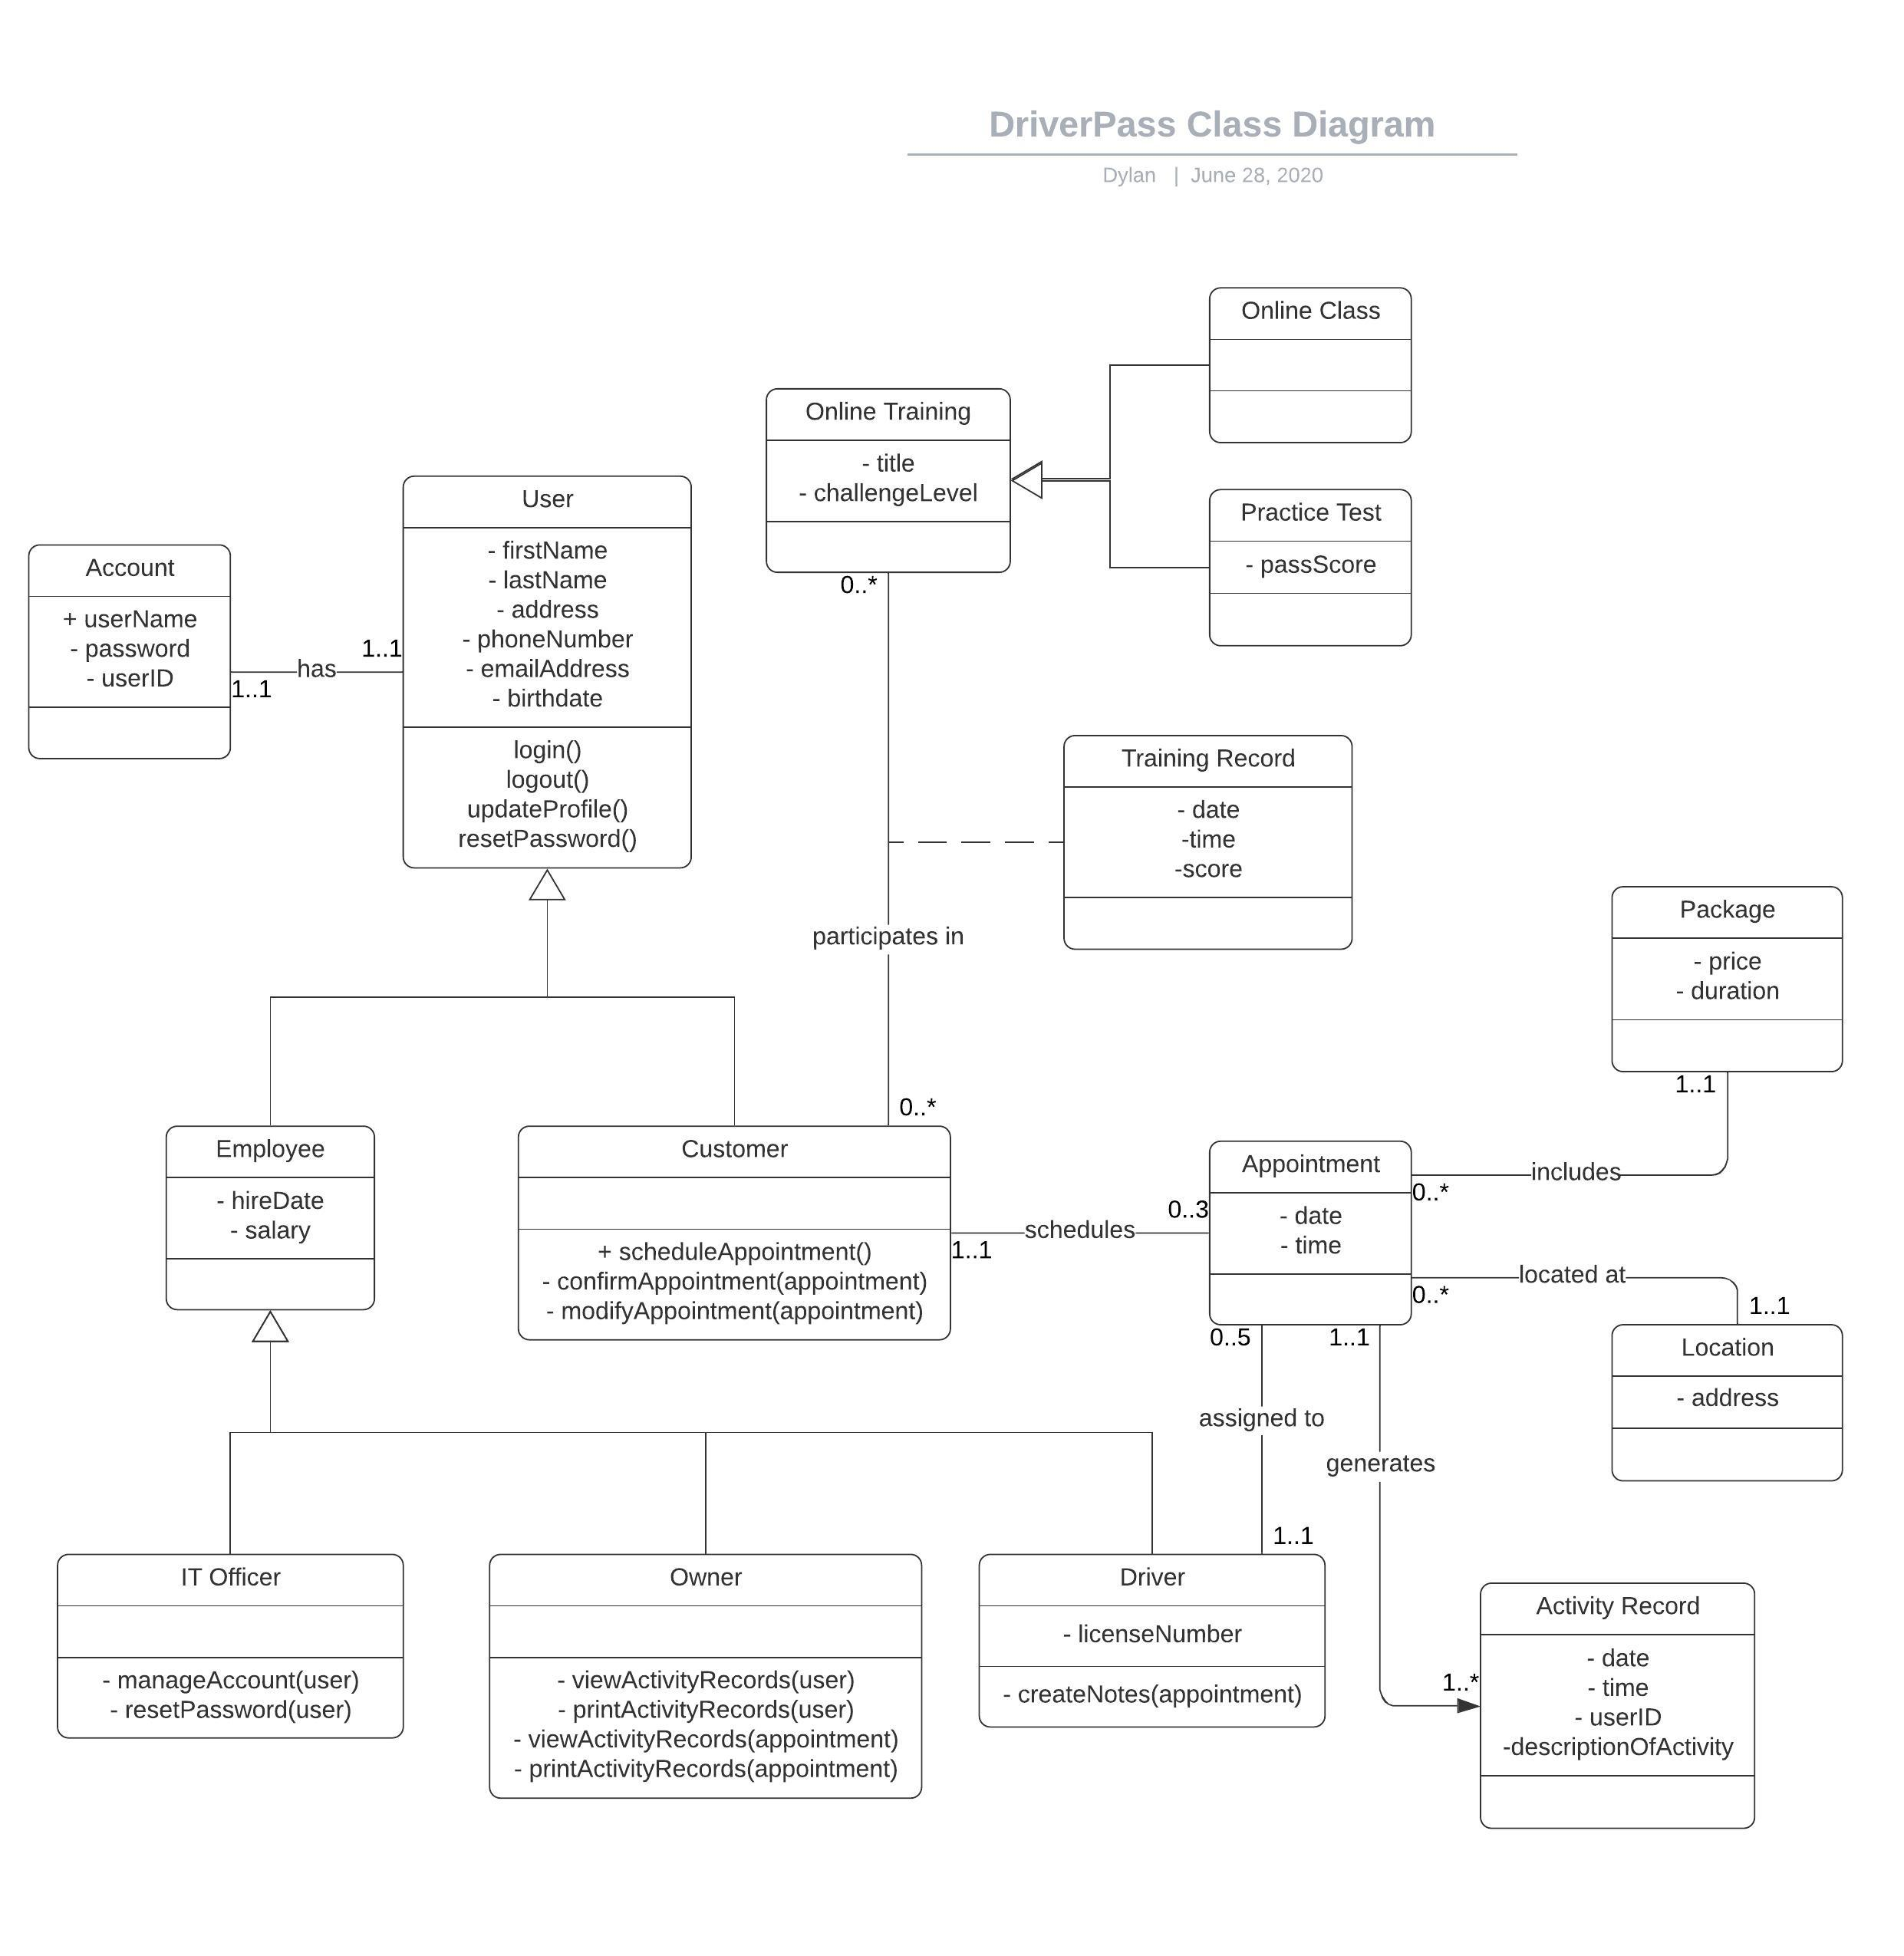

## Technical Requirements

The system should run on a Windows server for security and ease of use. Server should be accessible via web browser (IE, Microsoft Edge, Firefox, Chrome, Safari) or mobile app (iOS or Android). HTTPS security should be enforced for all logins. Office requires three computer terminals for use by secretary, IT officer, and company head. Office requires two dedicated phone lines: one for customer contact and appointment scheduling, and one for business communications. Portable devices (smartphones) are required, and will be issued to each driver for remote communication. Optionally, drivers can use their personal devices. For each operating region, software is required to monitor local DMV website, and automatically detect updates.